Chapter 1  
Research Foundations and Fundamentals

CHAPTER LEARNING OBJECTIVES

After reading this chapter, students should understand…

**1** How business research and data analytics complement each other.

**2** The language used by professional researchers.

KEY TERMS

Key terms are shown in **bold,** as they appear in the text, throughout the lecture notes.

PowerPoint

* A complete PowerPoint slide set comes with this chapter.
  + Slides are ordered as the chapter is organized.
  + Each, at minimum, contains the following:
  + Learning Objectives slide
  + Pullquote slide, key thought that opens this chapter
  + Exhibit slides, one or more per exhibit
  + Additional slides that cover critical concepts not covered by exhibits
  + Key Terms slide(s)
  + Additional Discussion Opportunities slides: You can arrange these slides within the slide set as desired. This slide section contains several types of slides; suggestions for using these slides are in the *Discussion and Project Ideas* section of this manual. The slides include all or some of the following:
    - Snapshot slides, one for each Snapshot; contains an image or graphic to serve as a visual anchor for the discussion.
    - PicProfile slides, one for each PicProfile; contains the image.
    - CloseUp slides, at least one per CloseUp; contains the images or graphs.
    - Additional Pullquote from thought leaders, at least one per chapter
    - PulsePoint: a statistic drawn from a research project that relates to some chapter concept.

Test Bank

The test bank for each chapter contains the following:

* Multiple-choice or true-false objective questions of one or more types, with answer noted in RED:
  + Definition-based questions on key terms and concepts
  + Application-based questions posing decision scenarios
  + Application-based questions asking for justification or explanation
* Essay Questions, with one possible answer noted in RED.

Connect

Connect is the location for several resources:

* **Quiz questions**
  + You select from this additional set of multiple-choice and true-false questions for each chapter to create a self-assessment quiz for that chapter. Each question provides a pop-up learning note for the correct answer, that you may opt to show (or not).
* **Connect Library for Instructors**
  + PowerPoint Slide Sets
* Instructors often modify these sets to reflect their own teaching style and pedagogy for a chapter’s material; you may opt to share these sets (or not) with your students, as presented or modified.
* Each slide sets contains the graphical exhibits contained in the text.
  + Instructor’s Manual for each chapter
  + Test Bank for each chapter
  + Written and video cases
  + Additional Materials Related to Cases (e.g., case discussion notes, data sets, video material, etc.)
  + Additional Materials Related to Chapters
  + Supplemental appendices on topics you may want to assign related to a chapter.
  + Supplemental chapter-related materials
* BRM13e_Top Research firms 2017.pdf
  + Sample Student Project
  + Excel Chart Templates
* **Connect Library for Students**
  + Written and video cases
  + Additional Materials Related to Cases (e.g., data sets, video material, etc.)
  + Additional Materials Related to Chapters
  + Supplemental appendices on topics.
  + Supplemental chapter-related materials
  + Sample Student Project
  + Excel Chart Templates

SmartBook

This is a, digital version of *Business Research Methods*, which can be accessed online via laptop.   It is linked to *Business Research Methods*’s Connect features. The content of *Business Research Methods* SmartBook is the same as the printed version of *Business Research Methods* but the digital features help focus a student’s learning on particular book content. Students pay for a subscription to *Business Research Methods* SmartBook for the duration of your term or semester.

* As the instructor, you may assign Business Research Methods SmartBook or  students may choose to subscribe to SmartBook on their own.
* If you want your students to have access to Business Research Methods SmartBook and its learning features, you will need to set up your Business Research Methods Connect course.

Discussion and Project Ideas

* **Snapshots**
  + ***Analytics Under Delivers Compared to its Hype***…An MIT/Sloan Management Review and SAS report on data analytics users.
  + ***Big verses Small Data***…how big data alone misled Lego and how a small research project revealed the strategy that pulled it back from near bankruptcy.
  + ***Research on Cyber Security***…How Alert Logic used research to discover cyber criminals’ paths.
  + ***Identifying and Defining Concepts***…Using presentations from professional business conferences to show the importance of understanding the language of research.

**What are the constructs and the operational definitions for those constructs?**

*First Paragraph*

In the first paragraph of the snapshot, the students should identify the following constructs: advertising optimization, advertising storytelling, ad blocking

* Advertising optimization might refer to number of people responding to a digital ad by clicking on the ad, or the sales resulting from the delivery of the correct digital advertising content to the customer most likely to respond.
* Advertising storytelling might refer to the use of an advertising story—either complete or installments—to deliver the advertiser’s message.
* Ad blocking might refer to the use by a potential customer of apps or permissions to block the delivery of an ad. But does it refer to ads never delivered or ads that are blocked after a few seconds.

Some management problems students might offer include: Increased ad blocking, and lower levels of ad optimization. You should encourage students to phrase these as undesirable management results rather than the customer action itself or the industry phrase for the action. Some examples of what student’s might offer using this different perspective:

* Lower levels of ad recall due to failure to see ads caused by the use of non-storytelling advertising techniques.
* Lower levels of ad recall due to failure to see ads caused by customer ad blocking.
* Lower prospect-to-customer conversion due to lower levels of ad follow-through (clicks on ads or web-site visits).
* Lower sales due to lower levels of ad follow-through (clicks on ads or web-site visits).
* Failure to change prospective prospect’s brand image or brand perception based on lower levels of ad delivery.

*Second Paragraph*

In the second paragraph of the snapshot, the students should identify several additional of constructs: digital ad viewability, transparency, trade association, trust.

* Viewability might be how many prospective customers view a digital ad (Google distinguishes the difference between a digital ad that is served verses one that is viewed; The Media Ratings Council just adopted the following as an operational definition of a viewable ad: “50% of an ads pixels are on screen for a minimum of 1 second.” You can see the Google study at "The Importance of Being Seen: Viewability Insights for Digital marketers and Publishers," Google, Novebmber 2014, downloaded April 6,2016 <https://think.storage.googleapis.com/docs/the-importance-of-being-seen_study.pdf>). Also, Google offers an example of a research infographic at: “Five Factors of Display Viewability” Google, November 2014, downloaded April 6, 2016 (<https://www.thinkwithgoogle.com/infographics/5-factors-of-viewability.html>).
* Ad transparency might refer to where an advertiser’s dollars are spent, but this general observation isn’t sufficient as an operational definition. Transparency is often divided into two types. One is called *financial transparency* (how much of an advertiser’s budget is spent by an advertising agency on media buys, data, technology or account service). But transparency also relates to *operational transparency* (where an ad is served and which metrics an ad optimization algorithm uses).
* Trade associations usually refer to professional groups founded and funded by businesses that operate in a specific industry. It’s important that the student operational definition specify that such groups define and set industry standards, perform public relations activities on behalf of the industry and their members, and do governmental lobbying. Students might see this as a concept rather than a construct; discourage them. As each trade association has its own mission and they very widely. Ron Amram, VP-media at Heineken USA, was referring to the American Association of Advertising Agencies (4As) and American National Advertisers, both powerful trade associations representing their very different groups.
* Trust is a belief that someone or something is reliable and truthful. But that doesn’t go far enough for an operational definition. How would you measure someone/something’s reliability? Truthfulness is the absence of lies. But how do you determine what is a lie? Someone will check Wikipedia and find “a statement that is known or intended by its source to be misleading, inaccurate, or false.” But as an operational definition, it doesn’t give you keys or clues to look for that are measurable. Someone could say ‘inaccuracy’ is determined by perspective. And truth or falsehood is also a matter of the factors considered. Generating the answers to these questions should lead to a lively discussion.

*Third Paragraph*

The key constructs students should identify are compelling advertising, commoditization in advertising, great advertising, and full value.

* Compelling advertising might refer to advertising that evokes an emotional response from its audience. But it might equally be advertising that gains attention, wins admiration or an industry award. Any emotional response is not okay; an operational definition spells out the acceptable emotional response. Any attention is not okay; the operational definition should spell out the level of attention and from whom. Any award is not okay; the operational definition should spell out what award.
* Commoditization might refer to advertising that is like every other advertising for the product class. So while we can generate commoditized ads for less, as they follow a formula, they usually fall victim to confusing the customer. For example, how many car ads have you seen that show a red car driving through a city street while heads turn. You lose the ability to distinguish the brand of car, let alone the message that brand is trying to deliver. Coming up with the operational definition of what is a commoditized ad—one that uses the same creative strategy as another ad in the same product class—might help, but only if the student could define ‘creative strategy’ and ‘product class’.
* Great advertising might refer to advertising that achieves its response or sales goals or be advertising that wins a Super Bowl ad competition or advertising that wins a Clio Award. Remind students that they have to have a consistent way to measure ‘great’.
* Full value might refer to what the advertising agency should be paid based on the worth of the ad based on its goal achievement, distinctive and memorable production values, creativity or something else. Full value is a price based on creativity and its success, as opposed to some standard fee—for example 15% of media buy dollars. Determining the factors that will be included in the calculation of the value is the exercise for the operational definition.

**What is the management problem revealed for advertisers and advertising agencies?**

The most important management problems are “How does the advertising agency regain the advertiser’s trust?” and “How do advertisers and their agencies keep customers from blocking ads?”

* **PicProfiles**
  + None in this chapter
* **CloseUp**
  + None in this chapter.
* **PulsePoint:** Published research reveals many ways that businesses use research. You might use such research findings to discuss a current phase of the research process or a current issue. This PulsePoint relates to hiring expectations of firms. You might use this finding to stimulate a discussion on how organizations might use research to track employee behavior on the job.
* **34**…The percent of employees who never consider what their bosses, clients, or colleagues think before posting to a blog, discussion forum, or social network.
* **Pullquote:** Use each chapter’s pullquote to discuss a current issue related to the chapter.
* This quote relates to the difference between data analytics and research. It’s the perfect opportunity to discuss the importance of each and the pitfalls of relying on only one:
* “As big data increases, we see a parallel growth in the need for ‘small data’ to answer the questions it raises.”

William C. Pink, senior partner

Creative Analytics

* Additional PullQuote; This quote relates to the importance of discovery for its own sake, but also discovery for a purpose. Anyone who saw the movie Hidden Figures (2016) can understand the importance of applying established tools in new ways to new data, and using the perspectives of new individuals to the race for space exploration. The engineers of NASA were attempting something that had not been done before—a real dilemma—and needed not only visionary leadership but new hypotheses to accomplish this.
* “Research is creating new knowledge.”

Neil Armstrong, Engineer and Astronaut

* Additional Pullquote: The quote below deals with the emergence in key performance indicators to inform. You can use this quote to discuss the disadvantages facing organizations that do not invest in research and analytical benchmarking.
* “Forward-thinking executives recognize that analytics may be the only true source of sustainable advantage since it empowers employees at all levels of an organization with information to help them make smarter decisions.”

Wayne Eckerson,

director of research, business applications and architecture group,

TechTarget

* Source: Wayne Eckerson, “Big Data Analytics: Profiling the Use of Analytical Platforms in User Organizations,” TechTarget, September 2011, p. 10, accessed March 5, 2012 (<http://docs.media.bitpipe.com/io_10x/io_103043/item_486870/Big%20Data%20AnalyticsMarkLogic.pdf>).
* **Additional Discussion or Project Ideas**
* The photograph related to reasoning shows an individual on a skateboard. Apply deductive and inductive reasoning to the image to develop conclusions about what will happen in the next photo frame.
* Show Exhibit 1-4. With recommendations from the students, complete the “Job Interest Construct” of the job redesign.   
  Terms to consider: Prior employment history; aptitude test results,
* Write several hypotheses that you have originated on the board; the topic is not important. Alternatively, have students propose some. Then compare each hypothesis against the checklist in Exhibit 1-10 in order to determine if it is a strong hypothesis or a weak one. Some ideas below:
* Chip makers who advertise will sell more packages than chip manufacturers who don’t advertise.
* Employees who take on leadership roles in projects, advance faster than those who act only as a team member on projects.
* Employees who maintain a healthy weight are more productive than those who are overweight.
* Machines that are maintained quarterly generate fewer defects than those maintained annually.
* Students who attend class will earn higher grades than those who don’t attend.
* **WWW Exercises:**
* Nielsen revealed its best-liked TV ads and its methodology on the following site. Have students use Exhibit 1-3 to discuss the methodology used to arrive at the Nielsen conclusions.
  + <https://www.marketingcharts.com/uncategorized-25514>

CHAPTER Exhibits

|  |  |
| --- | --- |
| **Exhibit Number** | **Exhibit title** |
| **1-1** | Where Business Collects Information |
| **1-2** | Some Sources of Business Intelligence |
| **1-3** | The Research Process |
| **1-4** | Constructs Composed of Concepts in a Job Redesign |
| **1-5** | Independent and Dependent Variables: Synonyms |
| **1-6** | A Summary of Variable Types |
| **1-7** | Relationships among Types of Variables |
| **1-8** | Why Didn’t Sales Increase? |
| **1-9** | Why Is Tracy Nelson’s Performance So Poor? |
| **1-10** | Checklist for Developing a Strong Hypothesis |
| **1-11** | Model of the Traditional Product Life Cycle Theory |

|  |  |
| --- | --- |
|  | **Notes an exhibit in the Research Process Series** |

CHAPTER Lecture Notes

The Role and Process of Research

* The research field is in the midst of upheaval in disruption.
* More than ever researchers are seen as insight providers, not just adding to the data pool but contributing to better business decisions.

## Research verses Data Analytics

* Every strategic and tactical decision starts with information. It is the manager’s decision whether he has sufficient information or needs more.
* Organizations are seeking competitive advantage by trying to analyze huge oceans of data —big data—collected from internal —decision support systems—and external databases, but not always with success.
* Exhibit 1-1 Where Business Collects Information
* Major example: Siemens AG
* Businesses are getting better at **data blending**combining data from separate data files into a new composite data file, and then querying that composite data file to help make decisions.
* Business intelligence provides managers with ongoing information about events and trends in the business environment.
* Exhibit 1-2 Some Sources of Business Intelligence
* Decision scenarios:
  + You’re the manager of a full-service restaurant. You’ve experienced significant turnover in your waiter/waitress pool, and some customers have commented that the once-friendly atmosphere is changing. Is this a problem for which business research should be used? Where will you begin in trying to solve this problem?
  + You’re the head of the state’s department of transportation. You must determine which roads and bridges will be resurfaced next year. You usually look at the roads and bridges with the most traffic, in combination with those representing the biggest economic disaster if closed. However, these are often located in the most affluent regions of the state. Because your decision has numerous operational, financial, and public relations ramifications, your manager suggests using business research to assist with your decision making. Should you authorize the research?

**SNAPSHOT**: Analytics Under-Delivers Compared to its Hype

## The Research Process

* **Business research** is a systematic inquiry that provides information to make decisions.
* More specifically, it is a process of planning, acquiring, analyzing, and disseminating relevant date, information, and insights to decision makers in ways that mobilize the organization to act in ways that maximize business performance.
* Business research attempts to provide the why so that predictions can be made to deal with the speed of decision making in ever changing enviroments.
* Businesses are often missing the ‘why’ in this deep dive into historical data.
* Research is a multi-stage process:
* Clarify the Research Question
* Design the Research
* Collect & Prepare the Data
* Analyze & Interpret the Data
* Report Insights and Recommendations
* Make the Management Decision

# Exhibit 1-3 models the sequence of the research process. Recycling, circumventing and skipping occur. Some steps are begun out of sequence, some are carried out simultaneously, and some may be omitted. The idea of a sequence is useful for developing a project and for keeping the project orderly as it unfolds. The research process begins with understanding the manager’s problem--the management dilemma. In other situations, a controversy arises, a major commitment of resources is called for, or conditions in the environment signal the need for a decision.

* In every chapter, we refer to this model as we discuss each step in the process.
* Exhibit 1-3 is an important organizing tool because it provides a framework for introducing how each process module is designed, connected to other modules, and then executed.
* Multiple types of projects can be labeled “business research.”

**SNAPSHOT**: Big verses Small Data

## *Research and the Scientific Method*

* The essential tenets of **scientific method** are:
* Clearly defined concepts, constructs, variables, methods, and procedures.
* Empirically testable hypotheses: a way exists to gather evidence that directly supports/refutes any hypothesis.
* Direct observation of phenomena (facts).
* Conclusions drawn from statistical evidence rather than inferred justification (educated guesses).
* The self-correcting process: ability to replicate and reassess validity of conclusions.

**SNAPSHOT**: Research on CyberSecurity

The Lanuage of Research

* To understand or conduct research, you need to use concepts, constructs, operational definitions, variables, hypotheses.
* The success of research hinges on (1) how clearly we conceptualize and (2) how well others understand the concepts we use.

## Concepts

* A **concept** is a generally accepted collection of meanings or characteristics associated with certain events, objects, conditions, situations, or behaviors.
* Concepts…
* are created when we classify and categorize events, objects, conditions, situations, or behaviors—identify common characteristics beyond any single observation.
* are acquired through personal experience or the experience of others.
* use words as labels to designate them; these words are derived from our experiences.
* have progressive levels of abstraction
* Most concepts used in research are ordinary; but when we need to label less ordinary ones, we borrow from non-business fields or other languages.

## Constructs

* A **construct** is an abstract idea specifically invented for a given research and/or theory-building purpose.
* We build or make up constructs.
* Exhibit 1-4 Constructs Composed of Concepts in a Job Redesign shows How Heather, an HR analyst at CadSoft uses concepts and constructs.
* A **conceptual scheme** depicts the relationships among all variables of interest.

## Operational Definitions

* Confusion about the meaning of constructs or concepts can destroy a research study’s value.
* Researchers use operational definitions rather than dictionary definitions.
* An **operational definition** is a definition stated in terms of specific criteria for measurement or testing.
* Decision scenario: using a student’s class year in research

**SNAPSHOT**: Identifying and Defining Constructs

## Variables

* A **variable** is a measurable symbol of an event, act, characteristic, trait, or attribute.
* In practice, one or more variablesare used as a substitute for a concept or construct*.*

## Independent and Dependent Variables

* The **dependent variable (DV** is of primary interest to the researcher and thus to his or her hypothesis; it is measured, predicted, or otherwise monitored and is expected to be affected by manipulation of an **independent variable (IV),** another variable of primary interest.
* The assignment of the variable type (dependent vs. independent) depends on the hypothesis the researcher is studying.
* Exhibit 1-5Independent and Dependent Variables: Synonyms
* Exhibit 1-6 A Summary of Variable Types
* Exhibit 1-7 Relationships among Types of Variables, provides a detailed example using research on the effects of a 4-day working week on productivity

## Moderating Variables

* A **moderating variable** (MV is a second independent variable believed to have a *significant* contributory effect on the original IV–DV relationship.

## Other Extraneous Variables

* **Extraneous** variables might conceivably affect a given relationship.
* **Control variables** (CV) are extraneous variables that we measure to determine whether they influence our results,
* **Confounding variables** (CFVs) may also have an effect, so we measure for them or group our results to study them.

## Intervening Variables

* The **intervening variable** (IVV) is a factor that theoretically affects the DV but cannot be observed or has not been measured; its effect must be inferred from the effects of the independent and moderating variables on the observed phenomenon.

## Hypotheses, Theories, and Models

## Hypotheses

* Hypotheses, theories and models serve researchers in different ways but are related.
* A **hypothesis** is an unsubstantiated assumption about the relationship between concepts and constructs; it drives the research.
* A **theory** is comprised of data-tested, supported hypotheses; it is derived from research.
* A **model** is a visualization of a theory; it is used for clarification and to enhance understanding.
* A hypothesis can be phrased as a declarative statement (descriptive) or a question about the relationship between two or more concepts or constructs that may be judged as true or false.
* Hypotheses are always conjecture and formulated for empirical testing/measurement.

## *Types of Hypotheses*

* + A **descriptive hypothesis** states the existence, size, form, or distribution of some concept/construct.
  + **A relational hypothesis** describes a relationship between two concepts/constructs.
    - With **correlational hypotheses** the variables being studied occur together, but there is no assumption of causation.
    - With **causal hypotheses** one variable being studied is assumed to cause a specific effect on other variables studied.
    - Causal hypotheses not only predict the cause (cause means roughly to “help make happen) but also the effect.
    - In proposing or interpreting causal hypotheses, the researcher must consider the direction of influence.

## *Reasoning and Hypotheses*

* + **Reasoning**—gathering facts consistent with the problem, proposing and eliminating rival hypotheses, deducing outcomes, developing crucial empirical tests, and deriving the conclusion— is pivotal to much of the researcher’s success.
  + Two types of reasoning are of great importance to research in forming and testing hypotheses: induction and deduction.

Induction

* + - In **induction** you start by drawing a conclusion from one or more particular facts or pieces of evidence.
    - The inductive conclusion is an inferential leap beyond the evidence presented—that is, although one conclusion explains the fact of no sales increase, other conclusions also might explain the fact.
    - Decision Scenario: Tracy Nelson’s sales performance
    - Image and Caption: Skateboarding

Deduction

* + - **Deduction** is a form of reasoning that starts with one or more true premises and the conclusion flows from the premises given.
    - For a deduction—the proof—to be correct and sound, it must be both true and valid: Premises (reasons) given for the conclusion must agree with the real world (true).
    - The conclusion must necessarily follow from the premises (valid).
    - Decision Scenario: Sara’s ethics

Combining Induction and Deduction

* + - John Dewey’s “double movement of reflective thought: Induction occurs when we observe a fact and ask, “Why is this?” In answer to this question, we advance a tentative explanation (hypothesis). The hypothesis is plausible if it explains the fact (event or condition) that prompted the question. Deduction is the process by which we test whether the hypothesis is capable of explaining the fact.
    - Decision Scenario: Effect of promotion on sales
    - Exhibit 1-8 Why Didn’t Sales Increase
    - Exhibit 1-9 Why is Tracy Nelson’s Performance So Poor

## *What is A Strong Hypothesis?*

* + Three conditions must be fulfilled:
    - Adequate for its purpose.
    - Testable.
    - Better than its rivals.
  + Exhibit 1-10 Checklist for Developing a Strong Hypothesis

## Theories

* A **theory** is an empirically-supported description of the relationships between concepts, constructs, and hypotheses that are advanced to explain or predict phenomena.
* A theory, therefore, is comprised of data-tested, supported hypotheses; it is derived from research.
* To the degree that our theories are sound (empirically supported) and fit the situation, we are successful in our explanations and predictions.
* Example: Product Lifecycle Theory

**SNAPSHOT**: Theory: Retinal Scan Verses RFID for Tracking Beef

## Models

* A **model**, therefore, is a representation of a theory or system that is constructed to study some aspect of that system or the system as a whole.
* A research model’s purpose is to increase our understanding, prediction, and control of the complexities of the environment.
* Exhibit 1-11 Model of the Traditional Product Life Cycle Theory

# Answers to Discussion Questions

## Terms in Review

**1. What is business research?**

Business research, as it is used in this text, is a systematic inquiry that provides information to guide managerial decisions. More specifically, it is a process of planning, acquiring, analyzing, and disseminating relevant data, information, and insights to decision makers in ways that mobilize the organization to take actions that maximize business performance.

**2 Distinguish among the following sets of items, and suggest the significance of each in a research context:**

a. **Concept and construct**—Concepts and constructs are both abstractions, the former from our perceptions of reality and the latter from some invention that we have made. A concept is a bundle of meanings or characteristics associated with certain objects, events, situations and the like. Constructs are images or ideas developed specifically for theory building or research purposes. Constructs tend to be more abstract and complex than concepts. Both are critical to thinking and research processes since one can think only in terms of meanings we have adopted. Precision in concept and constructs is particularly important in research since we usually attempt to measure meaning in some way.

b. **Deduction and induction**—Both deduction and induction are basic forms of reasoning. While we may emphasize one over the other from time to time, both are necessary for research thinking. Deduction is reasoning from generalizations to specifics that flow logically from the generalizations. If the generalizations are true and the deductive form valid, the conclusions must also be true. Induction is reasoning from specific instances or observations to some generalization that is purported to explain the instances. The specific instances are evidence and the conclusion is an inference that may be true.

c. **Operational definition and dictionary definition**—dictionary definitions are those used in most general discourse to describe the nature of concepts through word reference to other familiar concepts, preferably at a lower abstraction level. Operational definitions are established for the purposes of precision in measurement. With them we attempt to classify concepts or conditions unambiguously and use them in measurement. Operational definitions are essential for effective research, while dictionary definitions are more useful for general discourse purposes.

d. **Concept and variable**—Concepts are meanings abstracted from our observations; they classify or categorize objects or events that have common characteristics beyond a single observation (see a). One or more variables substitute for a concept or construct; values are assigned to the variable so it can be measured and any hypotheses based on them can be empirically tested. In informal usage, a variable is often used as a synonym for construct or property being studied.

e. **Hypothesis and Theory**—A hypothesis is a conjecture about a relationship between two or more concepts/constructs that is configured for empirical testing/measurement. A theory is a data-supported hypothesis; it is no longer conjecture. Hypotheses drive research; theories are derived from the results of research. While a theory can be derived from a single research project, we will have more faith in the accuracy of a theory if the results of multiple research projects confirm the theoretical conclusion.

You may want to extend this topic by asking students to develop a theory. For example, construct a theory that will explain the differences in academic success that various students achieve in a B-school:

## 

**3 Describe the characteristics of the scientific method.**

The scientific method emphasizes (1) direct observation of phenomena, (2) clearly defined variables, methods, and procedures, (3) empirically testable hypotheses, (4) the ability to rule out rival hypotheses, (4) statistical rather than linguistic justification of conclusions, and (6) the self-correcting process.

**4 Below are some terms commonly found in a management setting. Are they concepts or constructs? Give two different operational definitions for each.**

**a First Line Supervisor.** (construct)

1. For purposes of a given study a first line supervisor is anyone who is on the company roster with a job level of ‘‘M-1.”
2. An individual working in a line function supervising at least five employees of category “N-1.”

**b Employee morale.** (construct)

1. Degree of mental satisfaction among employees as represented by their score on the XYZ morale inventory.
2. Mental satisfaction measured as an equally weighted self-report on seven point scales:

Mental satisfaction at home: Excellent (1) Average (4) Poor (7)

Mental satisfaction at work: Excellent (1) Average (4) Poor (7)

**c Assembly line.** (concept)

1. An assembly line is any work arrangement that meets the following tests:
   * The work consists of performing specific tasks in a fixed sequence of successive workstations.
   * The work at a given station is repetitive.
   * Materials upon which work is performed moved through the sequence to various workstations rather than machines or workers moving to the material.
2. An assembly line is any process on the production floor of building A where the process leads to a gross value addition to the product.

**d Overdue account.**  (construct)

1. All accounts receivable that remain unpaid by the 5th day after the invoice date.
2. All accounts receivable that remain unpaid after the due date of payment, as applicable, based on terms of credit allowed to the vendor.

**e Leadership.** (construct)

1. An act of leadership shall be recorded when any member of the small groups under observation is:

1. Recognized by group members as their leader by their submission to his/her assignments to specific roles in one of the exercises, or

2. Agrees to his/her suggestion as to how to proceed in making assignments.

1. The degree of leadership embodied in a manager would be measured by:

1. The number of executives of rank K, and above, reporting to the executive directly or indirectly

2. The increase in the number of executives of rank K and above, reporting to the manager directly or indirectly, over the last three years

In keeping with management perceptions of weight to be assigned to various factors, (1) could be assigned a weight of 60% and (2) 40%, leading to an index of leadership. Personnel may be ranked on this basis.

**f Union democracy.** (construct)

The condition of union governance, in which the rank and file members exercise the power in the union, as measured by responses to the following three tests:

* + Are there free and open elections of leaders in which opposition slates are allowed free access to the members?
  + There are open and free discussion and vote by rank and file members on any contract approval
  + There are effective rank-and-file committee, board, or other type of organizational arrangement by which workers exercise effective oversight of union officials.

**g Ethical standards.** (construct)

* + Norms or standards for our behavior and relationships with others, that go beyond known legal standards or where legal standards do not exist.
  + Norms or standards that assure that no one is harmed or suffers known or anticipated adverse consequences from a decision.

**5 In your company’s management development program, there was a heated discussion between some people who claimed, “Theory is impractical and thus no good,” and others who claimed, “Good theory is the most practical approach to problems.” What position would you take and why?**

Student answers will vary. Sample answer:

The statement that “theory is impractical and thus no good” illustrates a misconception of the true meaning of theory. The second quotation is more to the point: there is nothing so practical as a good theory (Kurt Lewin) because of the power it gives us to explain and predict the target phenomenon.

We use theory constantly as we explain why certain events occur or why one procedure succeeds and another does not. Theory represents an identification of key causal relationships, which explain outcomes in a variety of situations. It is an effort to extract the essence of relationships, ignoring less important contextual factors. The adequacy of a theory comes from its capacity to explain phenomenon in a variety of contexts and situations and this is referred to as its capacity to “travel.” Often, theories are too simplistic, and therefore lack explanatory power across situations. The solution lies in improving the theory, possibly introducing more variables, rather than rejecting the central concept.

**6 An automobile manufacturer observes the demand for its brand increasing as per capita income increases. Sales increases also follow low interest rates, which ease credit conditions. Buyer purchase behavior is seen to be dependent on age and gender. Other factors influencing sales appear to fluctuate almost randomly (competitor advertising, competitor dealer discounts, introductions of new competitive models).**

**a If sales and per capita income are positively related, classify all variables as dependent, independent, moderating, extraneous, or intervening.**

One scheme for assessing the variables:

|  |  |
| --- | --- |
| Car Sales (DV) | Buyer gender - EV |
| Per Capita Income (IV) | Competitor advertising - MV |
| Ease of credit access (EV) | Competitor dealer discounts - MV |
| low interest rates - MV | Introduction of competitor models - MV |
| Buyer age - EV |  |

Car Sales (DV) will increase as per capita income increases (IV), as long as low interest (IVV) increase ease of access to credit among younger (EV) men (EV) and competitors do not introduce more attractive models (EV), increase advertising (EV), or increase their discounts (EV).

**b Comment on the utility of a model based on the hypothesis.**

Given that buyer behavior is fickle with respect to ego-involved purchases (e.g. car), and given the number of uncontrollable extraneous variables, a model based on the above theory is unlikely to be relevant for any about of time.

**Making Research Decisions**

**7 You observe the following condition: “Our female sales representatives have lower customer defections than do our male sales representatives.”**

**a Propose the concepts and constructs you might use to study this phenomenon.**

**b How might any of these concepts and/or constructs be related to explanatory hypotheses?**

There are a variety of answers to this question. One example might be:

A. Concepts—sales representative, male, female  
Constructs—customer defection.

B. Female sales representatives who are more culturally supported in establishing and maintaining relationships extend that personal behavior into the work place.

Lower customer defections = fewer current customers lost at time of contract renewal resulting in a smaller customer defection percentage.

Customer defection percentage = the number of customers who do not renew their contract during the measurement period divided by the total number of customers at the start of the measurement period.

**8 You are the office manager of a large firm. Your company prides itself on its high-quality customer service. Lately complaints have surfaced that an increased number of incoming calls are being misrouted or dropped. Yesterday, when passing by the main reception area, you noticed the receptionist fiddling with his hearing aid. In the process, a call came in and would have gone unanswered if not for your intervention. This particular receptionist had earned an unsatisfactory review three months earlier for tardiness. Your inclination is to urge this 20-year employee to retire or to fire him, if retirement is rejected, but you know the individual is well liked and seen as a fixture in the company.**

**a Pose several hypotheses that might account for dropped or misrouted incoming calls.**

**b Using the double movement of reflective thought, show how you would test these hypotheses.**

Hypothesis 1—Receptionist misdirects calls due to his inability to correctly hear the problem as stated by the caller.

The above hypothesis is induced from the situation described in the problem. From the hypothesis we must be able to deduce some other factual conditions implied by this hypothesis. For example:

Fact 1—The complaints of misdirected calls only occur when the 20-year employee works the reception desk.

Fact 2—A fully hearing employee does not generate complaints of misdirected calls.

Fact 3—Employee has requested two sick days in the last 3 months for ear-related infections.

Hypothesis 2—A faulty switch causes the misrouted calls.

Fact 1—Switch A is tested by placing several sample calls and the calls are correctly routed.

Fact 2—Switch B is tested by placing several sample calls and the calls are misdirected.

**From Concept to Practice**

**9 Using Exhibits 1-8 an 1-9 as your guides, graph the inductions and deductions in the following statements. If there are gaps, supply what is needed to make them complete arguments.**

**a Repeated studies indicate that economic conditions vary with—and lag 6 to 12 months behind—the changes in the national money supply. Therefore, we may conclude the money supply is the basic economic variable.**

**b Research studies show that heavy smokers have a higher rate of lung cancer than do nonsmokers; therefore, heavy smoking causes lung cancer.**

**c Show me a person who goes to church regularly, and I will show you a reliable worker.**

A. 1. If money supply is the basic economic variable, then economic condition changes will parallel it with a lag.

2. Economic condition variations lag money supply by 6-12 months.

3. Therefore, money supply is the basic economic variable. (Induction)

B. 1. If smoking causes lung cancer, heavy smokers will have a higher lung cancer rate than non-smokers.

2. Heavy smokers do have a higher lung cancer rate.

3. Heavy smoking causes lung cancer. (Induction)

C. 1. If a person goes to church regularly, this person is a reliable worker.

2. “Bob” goes to church regularly.

3. “Bob” is a reliable worker. (Deduction)

**Note:** Three is a valid deduction from the major premise (1). The truth of the major and minor premises may be challenged: church attendance and reliability in the workplace must be unequivocally connected and “Bob” must be a person, not my dog.

**From the Headlines**

**10 Chipotle Mexican Grill continues to suffer from perception issues after a string of outbreaks including E.coli worried customers about the safety of eating at the fast casual chain. Their strategy for getting customers back into their restaurants was to give away free tacos, burritos and chips. And while their customer survey scores are improving they are still operating at a loss. What concepts and constructs, and operations definitions, should any future research deal with?**

Concepts/Constructs of interest

* + Safe Food (construct)…food that will not make you sick
  + Perception of Safe Food…whether a Chipotle customer expects to get sick from food prepared in the restaurant.
  + Safe food preparation environment (construct)…specific government-approved procedures in place (refrigeration, employee cleanliness, grill cleaning, food delivery, etc. ) to ensure safe food
  + Fast casual chain (construct)…a group of restaurants that does not offer full table service, but promises higher quality food by using few frozen or processed ingredients during food preparation.
  + Customer satisfaction score (construct) …on a survey, a 9 or 10 on a ten-point scale asking whether Chipotle exceeded the customer’s expectations.

# Additional Discussion Opportunities

**Video or Written Case Discussion**

You will find a description of each case in the Case Abstracts section of the textbook. Cases and case supplement, including discussion guides, are available in Connect or downloadable from www.mhhe.com/schindler13e.Cases appropriate for discussion of concepts in this chapter include the following.

* Campbell Ewald: R-E-S-P-E-C-T Spells Loyalty
* HeroBuilders.com
* Open Doors: Extending Hospitality to Travelers with Disabilities

**Additional Discussion Question:**

**Investment manager Bernard Madoff’s hedge fund Ascot Partners was a giant scam will likely be the finance story remembered from the last decade. It is estimated that Madoff stole an estimated $50 billion from noteworthy individuals and institutional investors, and he covered the crime by creating fictional financial statements for each investor. If you were an institutional investor, how might employing the tenants of scientific method have protected your organization from this Ponzi scheme?**

This question is designed to generate a brainstorming session in class of what types of research are possible within the area of finance. Students may quickly come up with such ideas as studying, in detail, the financial statements provided by Ascot Partners, comparing these statements against the returns of other investment statements received by the institutional investor. If you ask your students to dig deeper, they may come up with doing a search on the companies on which the hedge fund was invested. It is reported that the statements provided, which it is reported were falsified, contained some companies that didn’t exist and, for those that did exist, returns that were far out of line with the industry’s performance. Doing some research on the specific industries in which the hedge fund was invested might also have given the institutional investor some protection. Some students may raise the issue that institutional investors hire firms like Ascot Partners to provide the expertise in researching companies and investing that the institutional investor does not have. That is a good time to discuss if the buyer of research has any obligation to insure that the research company it hires has the expertise and skill needed to do the research desired. It is also reported that Madoff’s fund falsified reports provided to substantiate the statements provided. Thus, Madoff actually falsified research.

**Prior Edition Snapshots for Discussion**

Referenced URLs may have changed as some companies have merged and/or are renamed.



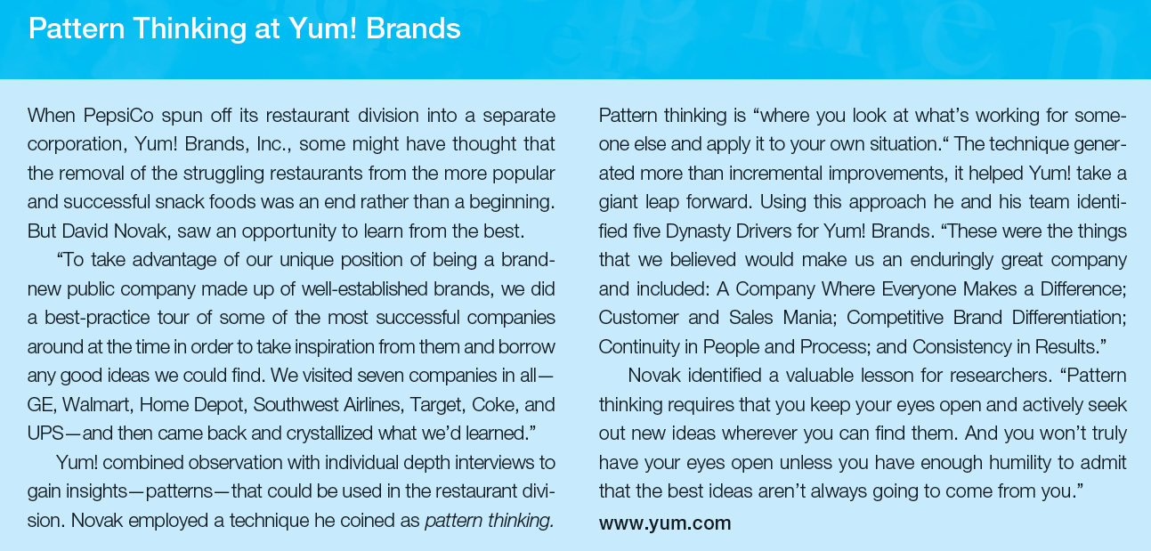

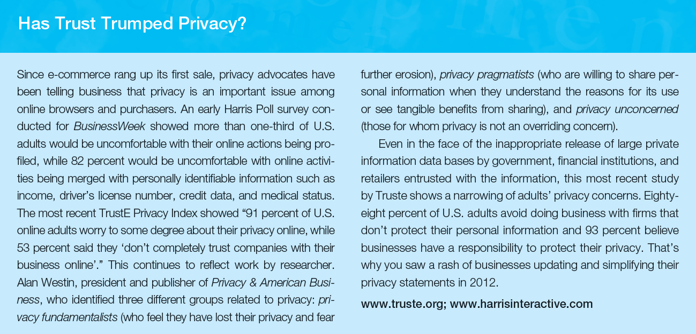

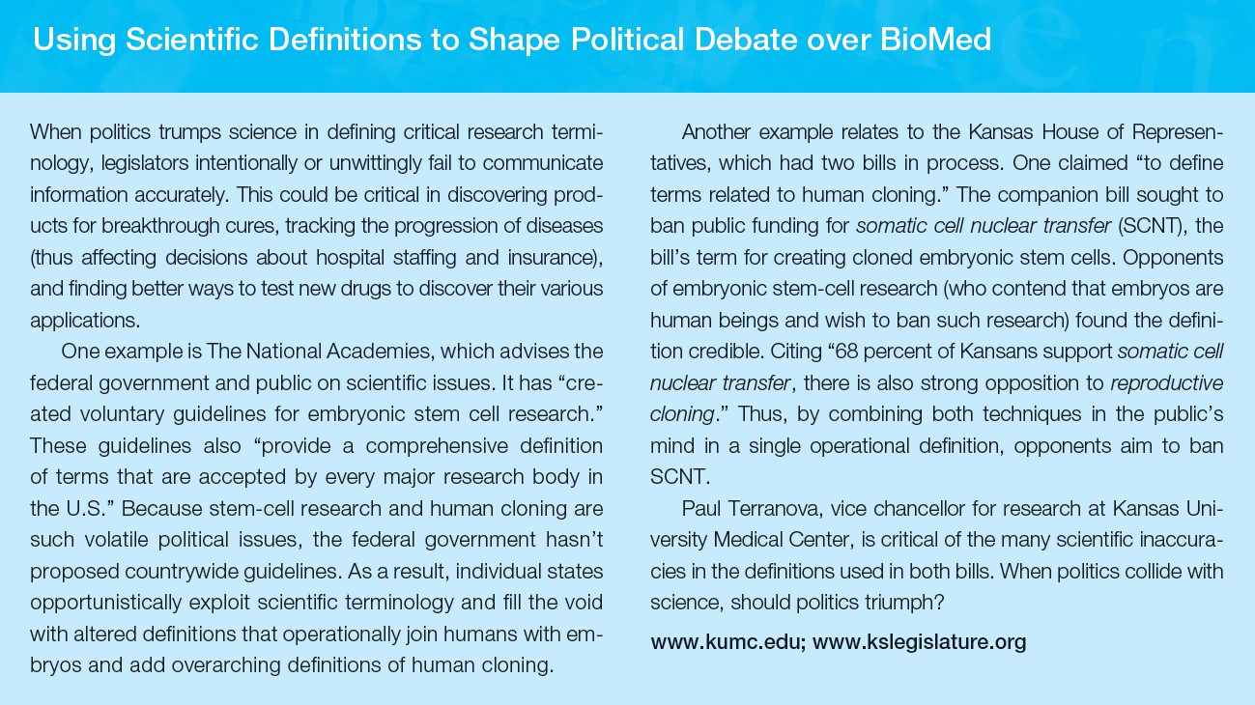

**Prior Edition Images for Discussion**

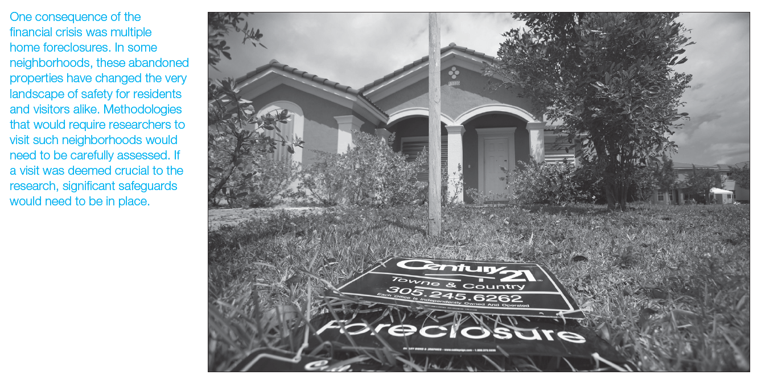

**Prior Edition Exhibits for Discussion**

The Role of Reasoning in Model Development

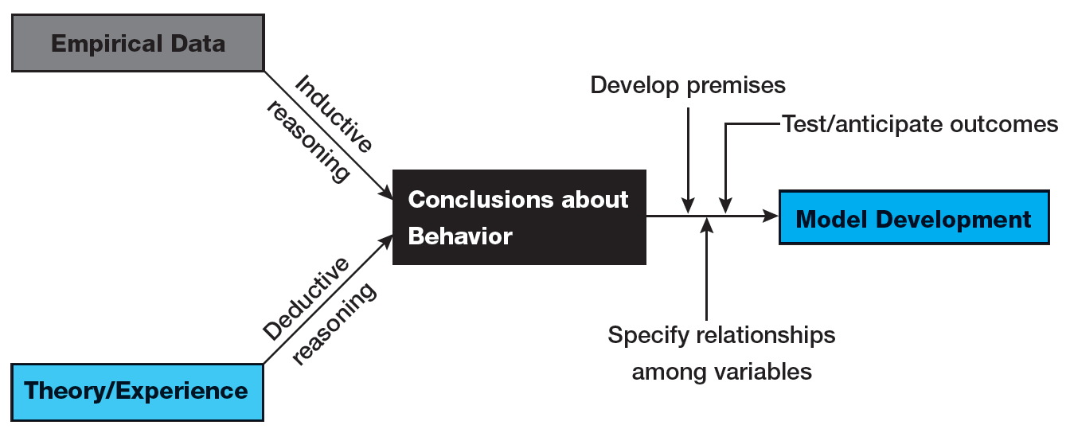

The Seven Basic Principles of the U.S. Safe Harbor Agreement

